IaC Provisioning for Telecomm System
  - Course Name: DevOps

Institution Name: Medicaps University – Datagami Skill Based Course

Student Name(s) & Enrolment Number(s):
Sr no | Student Name | Enrolment Number
1 | Isha Joshi | EN22CS301438
2 | Harsh Chouhan | EN22CS301387
3 | Goutam Choudhary | EN22CS301370
4 | Goutam Sharma | EN22CS301374
5 | Harshita Chouhan | EN22CS301406

Group Name: 03D4
Project Number: DO-39
Industry Mentor Name:
University Mentor Name: Prof. Avnesh Joshi
Academic Year:2026

Problem Statement & Objectives

Problem Statement

In modern telecom systems, deploying applications manually involves multiple steps such as environment setup, dependency installation, configuration, and deployment. This process is time-consuming, error-prone, and difficult to scale. Additionally, lack of automation leads to inconsistencies between development and production environments, resulting in system failures and downtime. There is also no efficient mechanism to handle continuous integration, automatic deployment, or infrastructure provisioning. Therefore, a need arises for a system that automates the entire deployment lifecycle while ensuring scalability, reliability, and consistency.

Project Objectives

- To design and implement an automated DevOps pipeline for a telecom application
- To eliminate manual deployment processes using CI/CD automation
- To containerize the application using Docker for platform-independent execution
- To deploy the application using Kubernetes for scalability and high availability
- To implement Infrastructure as Code (IaC) using Terraform for automated infrastructure provisioning
- To deploy and host the application on a cloud platform (AWS EC2)
- To ensure system reliability, consistency, and ease of maintenance

Scope of the Project
This project covers the complete lifecycle of application deployment using DevOps practices. It includes application development, containerization, continuous integration, continuous deployment, orchestration, and cloud hosting. The system is designed to simulate real-world deployment scenarios but is limited to a basic telecom dashboard application without advanced telecom functionalities. The scope includes

local and cloud-based deployment but does not include advanced production-level features like monitoring, logging, and security integration.

Proposed Solution
2.1 Key features

- Automated CI/CD pipeline triggered on every code push
- Containerized application using Docker ensuring environment consistency
- Kubernetes-based deployment with multiple replicas for high availability
- Self-healing mechanism where failed containers are automatically restarted
- Infrastructure provisioning using Terraform for repeatable deployments
- Cloud deployment on AWS EC2 for real-world accessibility
- Scalable architecture allowing dynamic increase in application instances
- Reduced manual effort and improved deployment efficiency

  - Overall Architecture / Workflow

The workflow of the project follows a structured DevOps pipeline:
- Development Phase:
The telecom application is developed using Node.js and Express.js, providing backend functionality and API endpoints.
- Version Control:
The code is stored and managed using Git and GitHub, enabling version tracking and collaboration.
- CI/CD Automation:
Whenever code is pushed to the repository, GitHub Actions automatically triggers a pipeline that performs build and deployment steps.
- Containerization:
The application is packaged into a Docker container using a Dockerfile, ensuring it runs consistently across different environments.
- Kubernetes Deployment:
The Docker container is deployed on a Kubernetes cluster where multiple replicas are created. Kubernetes ensures load balancing, scaling, and self-healing.
- Infrastructure Provisioning:
Terraform is used to automate the provisioning of infrastructure, such as creating and running Docker containers, making deployments repeatable and consistent.

- Cloud Deployment:
The application is deployed on AWS EC2, making it accessible over the internet via a public IP address.
- User Access:
End users can access the telecom dashboard through a web browser.

  - Tools & Technologies Used

- Frontend: HTML, CSS (for user interface)
- Backend: Node.js, Express.js (server-side logic and APIs)
- Version Control: Git, GitHub (code management and collaboration)
- CI/CD: GitHub Actions (automated pipeline execution)
- Containerization: Docker (application packaging and portability)
- Orchestration: Kubernetes (container management, scaling, and reliability)
- Infrastructure as Code: Terraform (automated infrastructure setup)
- Cloud Platform: AWS EC2 (hosting and deployment)

Results & Output

  - Outputs

- Successful execution of CI/CD pipeline in GitHub Actions
- Running Docker containers displayed using docker ps
- Kubernetes pods running successfully using kubectl get pods
- Kubernetes services exposing the application
- Terraform successfully provisioning infrastructure

  - Reports / dashboards / models

- CI/CD workflow visualization showing different stages (test, build, deploy)
- Kubernetes deployment status and replica management
- Terraform execution logs (plan and apply outputs)

- System output displayed via telecom dashboard (simulated metrics like uptime, users, etc.)
Key Outcomes
- Achieved complete automation of application deployment
- Reduced dependency on manual configuration and setup
- Improved consistency across development and production environments
- Enabled scalability through Kubernetes deployment
- Demonstrated Infrastructure as Code for efficient resource management
- Successfully deployed application on cloud platform
- Gained hands-on experience with real-world DevOps tools and workflows

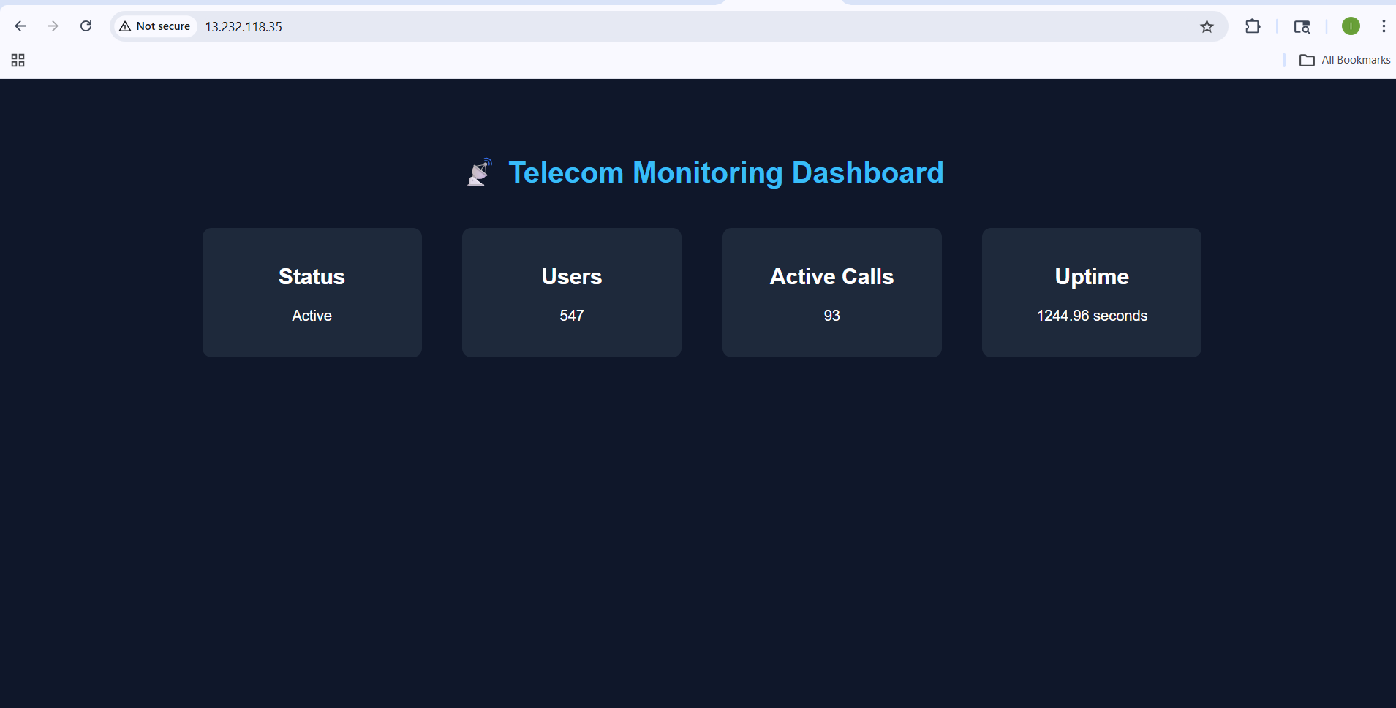

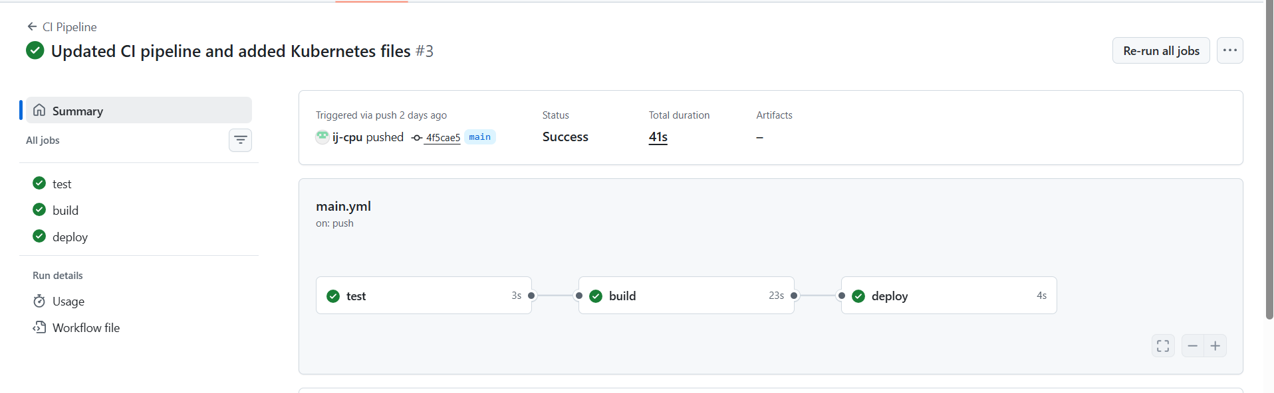

Conclusion
This project successfully implements a complete DevOps pipeline for a telecom application, integrating multiple modern tools and technologies such as Docker, Kubernetes, GitHub Actions, Terraform, and AWS. The project demonstrates how automation can significantly improve the efficiency, reliability, and scalability of application deployment. By eliminating manual processes and introducing CI/CD practices, the system ensures faster and error-free deployments. The use of Kubernetes enables high availability and scalability, while Terraform ensures consistent infrastructure provisioning. Overall, this project provides a strong foundation for understanding real-world DevOps practices and cloud-based deployments.

Future Scope & Enhancements

- Integration of monitoring tools like Prometheus and Grafana for performance tracking
- Implementation of logging systems for better debugging and analysis
- Deployment on managed Kubernetes services like AWS EKS
- Integration of database systems for storing telecom data

- Implementation of auto-scaling based on real-time traffic
- Adding security features such as authentication and HTTPS
- Enhancing CI/CD pipeline with testing and security scanning stages
- Using load balancers for improved traffic distribution
- Expanding the application with advanced telecom functionalities

